Larry Lawn Chair
(from Darwin Awards web site - 02 November 2000)
A classic from the Darwin awards archive
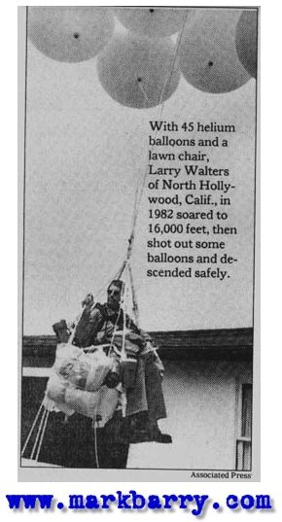
(1982, California) Larry Walters of Los Angeles is one of the few to contend for the Darwin Awards and live to tell the tale. "I have fulfilled my 20-year dream," said Walters, a former truck driver for a company that makes TV commercials. "I'm staying on the ground. I've proved the thing works."
Larry's boyhood dream was to fly. But fates conspired to keep him from his dream. He joined the Air Force, but his poor eyesight disqualified him from the job of pilot. After he was discharged from the military, he sat in his backyard watching jets fly overhead.
He hatched his weather balloon scheme while sitting outside in his "extremely comfortable" Sears lawnchair. He purchased 45 weather balloons from an Army-Navy surplus store, tied them to his tethered lawnchair dubbed the Inspiration I, and filled the 4' diameter balloons with helium. Then he strapped himself into his lawnchair with some sandwiches, Miller Lite, and a pellet gun. He figured he would pop a few of the many balloons when it was time to descend.
Larry's plan was to sever the anchor and lazily float up to a height of about 30 feet above his back yard, where he would enjoy a few hours of flight before coming back down. But things didn't work out quite as Larry planned.
When his friends cut the cord anchoring the lawnchair to his Jeep, he did not float lazily up to 30 feet. Instead, he streaked into the LA sky as if shot from a cannon, pulled by the lift of 42 helium balloons holding 33 cubic feet of helium each. He didn't level off at 100 feet, nor did he level off at 1000 feet. After climbing and climbing, he leveled off at 16,000 feet.
At that height he felt he couldn't risk shooting any of the balloons, lest he unbalance the load and really find himself in trouble. So he stayed there, drifting cold and frightened with his beer and sandwiches, for more than 14 hours. He crossed the primary approach corridor of LAX, where Trans World Airlines and Delta Airlines pilots radioed in reports of the strange sight.
Eventually he gathered the nerve to shoot a few balloons, and slowly descended. The hanging tethers tangled and caught in a power line, blacking out a Long Beach neighborhood for 20 minutes. Larry climbed to safety, where he was arrested by waiting members of the LAPD. As he was led away in handcuffs, a reporter dispatched to cover the daring rescue asked him why he had done it. Larry replied nonchalantly, "A man can't just sit around."
The Federal Aviation Administration was not amused. Safety Inspector Neal Savoy said, "We know he broke some part of the Federal Aviation Act, and as soon as we decide which part it is, a charge will be filed."
Footnote:
Larry's efforts won him a $1,500 FAA fine, a prize from the Bonehead Club of Dallas, the altitude record for gas-filled clustered balloons, and a Darwin Awards Honorable Mention. He gave his aluminum lawnchair to admiring neighborhood children, abandoned his truck-driving job, and went on the lecture circuit. He enjoyed intermittent demand as a motivational speaker, but said he never made much money from his innovative flight.

